CS 255 System Design Document Template

This template lays out all the different sections that you need to complete for Project Two. Each section has guidance to prompt your thinking. You will need to continually reference the interview transcript as you work to make sure that you are addressing your client’s needs. There is no required length for the final document. Instead the goal is to complete each section based on what your client’s needs are. Remove this note when you are finished, and replace all bracketed text with the relevant information.

UML Diagrams

UML Use Case Diagram
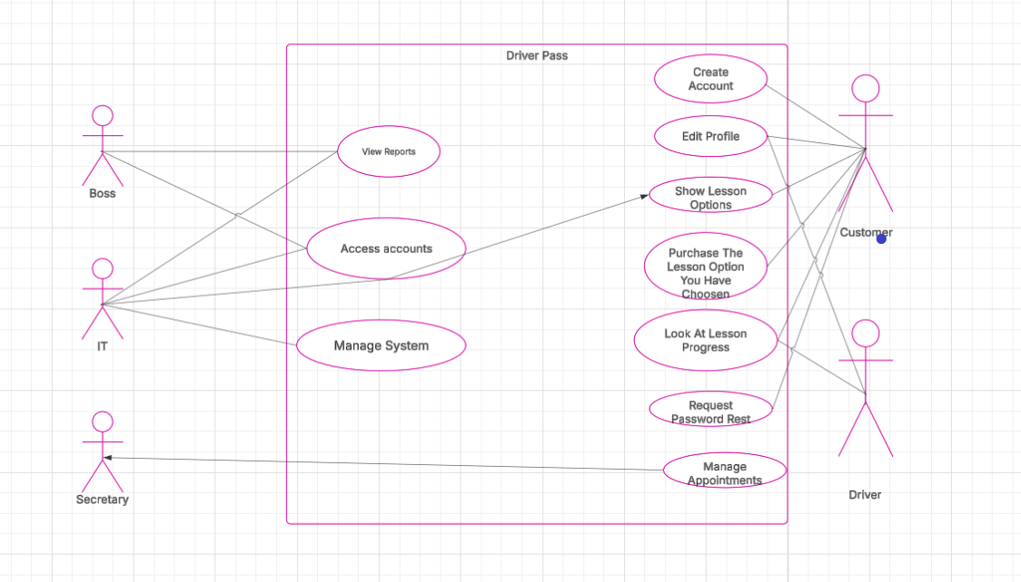

UML Activity Diagrams
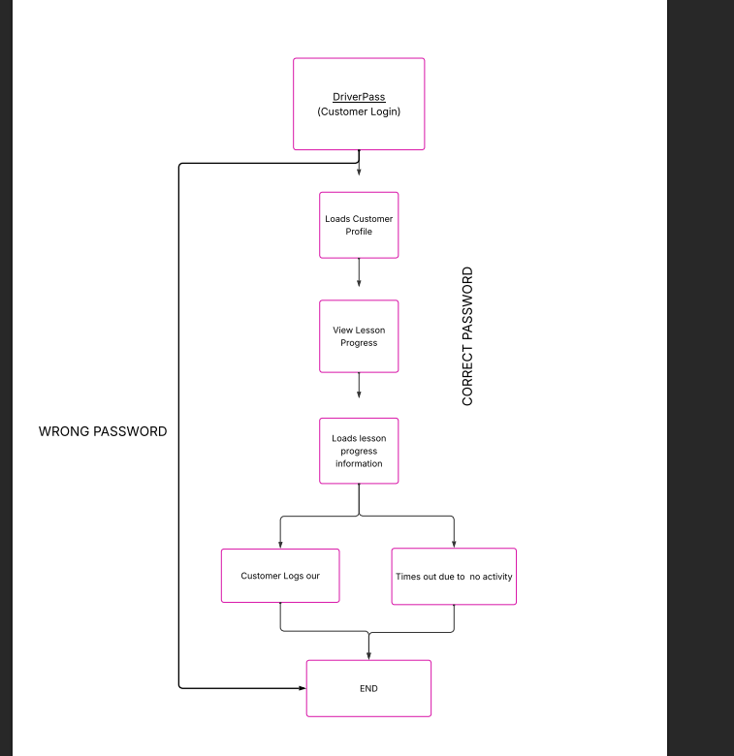
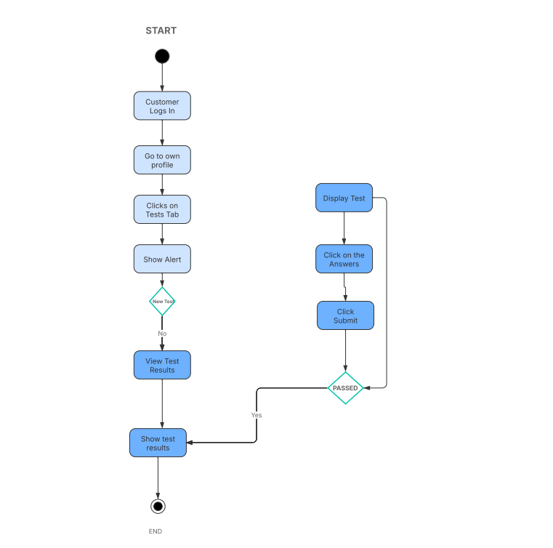

UML Sequence Diagram
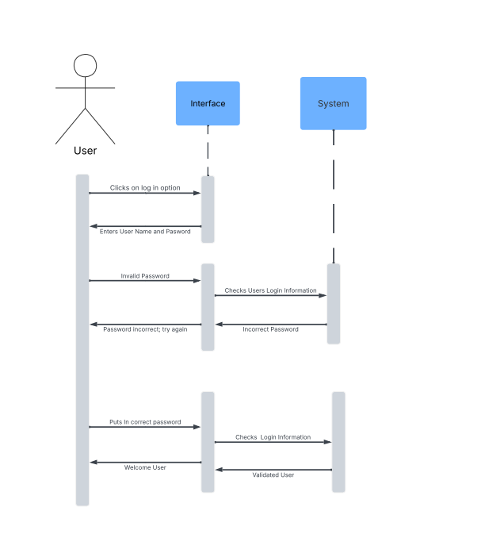

UML Class Diagram
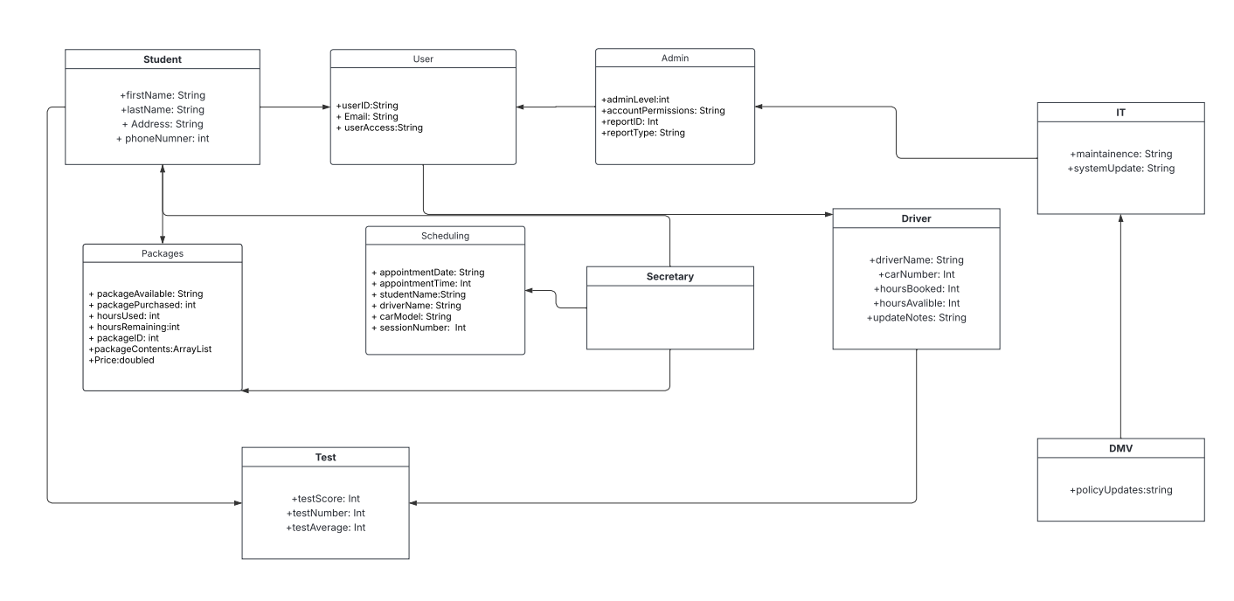

Technical Requirements
The platform will give each user a personalized dashboard that tracks how far they’ve come in both their written practice and their on-road training. From that same space, users can arrange new appointments, adjust existing ones, or remove them entirely.
System administrators will have full control over staff access, including the ability to activate or retire employee accounts. They will also be able to send secure password-recovery links to anyone who needs to update their login credentials.
Driving instructors will have a dedicated area where they can record observations, update lesson notes, and keep ongoing feedback for every student. All features are expected to respond instantly, without lag or performance issues. Photos of students and instructors will appear throughout the interface to help identify accounts quickly. Anyone who forgets their password will be able to reset it through a guided self-service process.
During each driving session, the system will show key details such as remaining time and other session-specific information. A protected online checkout system will allow customers to purchase training services safely. Staff at the front desk will have tools to schedule appointments for walk-in visitors.
The platform will include the three training packages offered by DriverPass and give administrators the ability to revise, expand, or remove those packages as business needs change. It will remain aligned with current DMV rules and updates. To safeguard customer data, the system will use multifactor authentication.
All data and services will run on a cloud-hosted environment, accessible entirely through a web browser. The system must scale smoothly as the number of users grows. It will work across major operating systems, including Windows, macOS, Linux, Android, and iOS. Users will only need an internet connection and a device to access the service. Because the solution is cloud-based, DriverPass will not need to maintain extensive hardware on-site.

